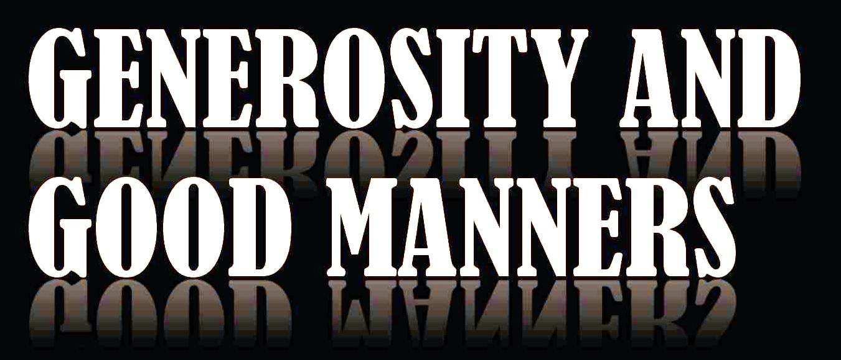
AIMS
- To define what good manners are
- To visualize the good and bad manners
- To learn the Comenius song
- To be able to demonstrate understanding of the meaning of generosity

TOPİCS
- Being generous with money
- Drawing competition
- Visiting the old and having breakfast with them
- Growing in generosity
- Creating a display
- Preparing logos for the project
- Visiting the war place in Çanakkale

- The Comenius Song
- The Charity for the blind
- The play
- Logo Works
- The contests
- Drawings

ACTİVİTES
